Overview
The Feedback function allows you to submit feedback, either compliment, suggestion or complaint, through an online channel to DVA at any time.
To submit feedback via MyAccount you must be logged into MyAccount.
When submitting feedback, fields marked with a red asterisk (*) are mandatory.

The Lodge feedback screen.
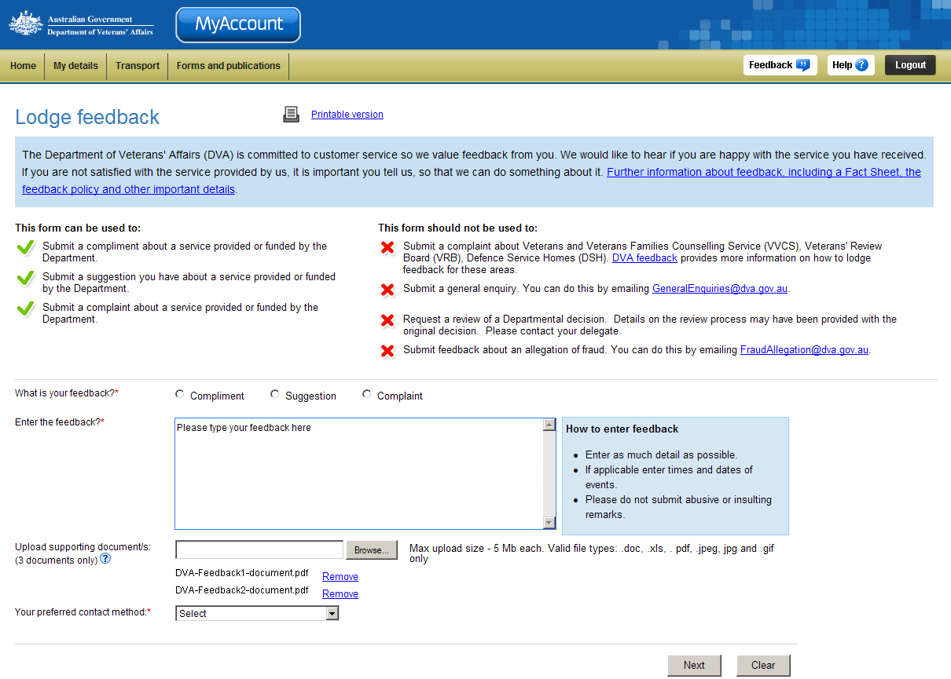
Types of feedback that can be submitted.
Feedback form.

Submitting feedback
To submit feedback:
- In the What is your feedback section, select the radio button for the type of feedback you would like to submit e.g. Compliment, Suggestion or Complaint.
- In the Enter the feedback field, enter as much detail as possible about the feedback.
 | If you chose the feedback type ‘Complaint’, a new field displays.  From the What outcome are you looking for drop down list, select the outcome your would like e.g. advice, apology, contact for discussion or no further action.
- Upload any relevant documents if required by clicking on the Browse button.
- From the Your preferred contact method drop down list, select your ideal contact method e.g. phone, email, post or I do not wish to be contacted.
When a method of contact is selected e.g. phone, your phone number stored in MyAccount will display.
If you wish to change you contact details, please go to the Contact details page and update your details.

- Click on the Next button.

The Confirm feedback screen displays.
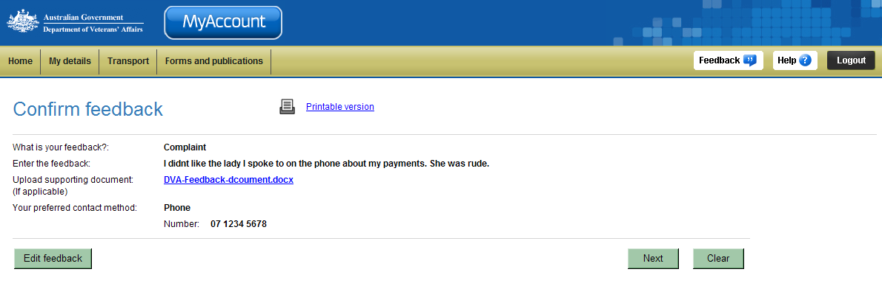
- Review your feedback.
Click on the Edit feedback button to be taken to the Lodge feedback screen to update the details of the feedback.
- Click on the Next button to submit the feedback.

The Feedback screen displays.
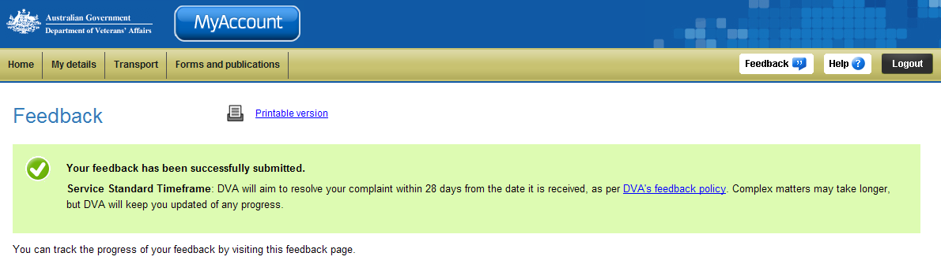
Your feedback has been successfully submitted. Please note the service standard timeframe is within 28 days.

Viewing the progress of your feedback
As your feedback is processed, you can monitor how DVA is responding to your feedback.

The Feedback screen.
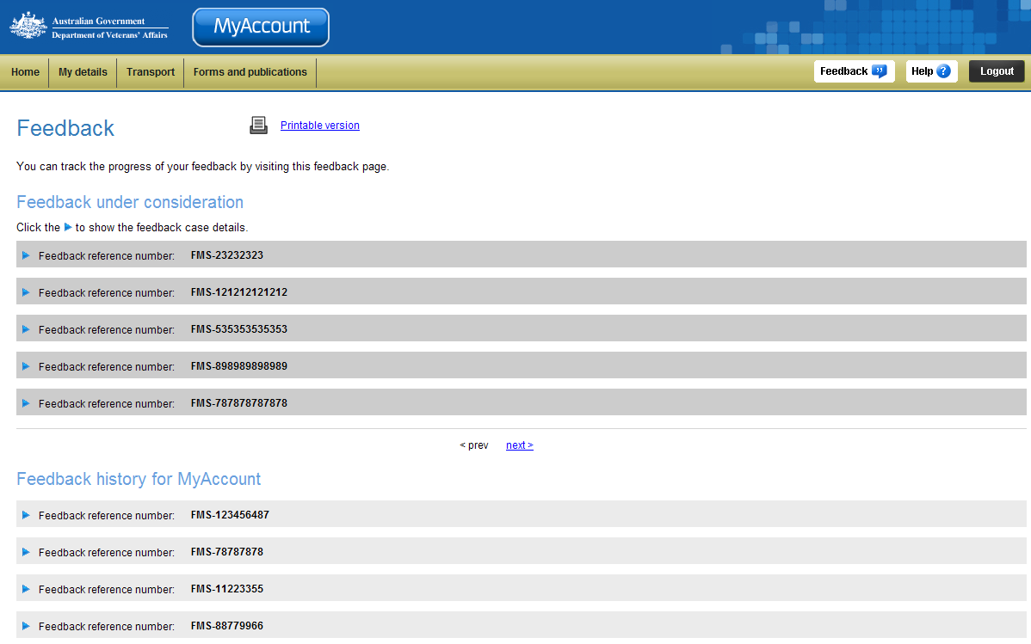
Feedback currently
in progress
Finalised feedback
- Feedback can be expanded to display further details by clicking on the icon.

The feedback is expanded to display further details.
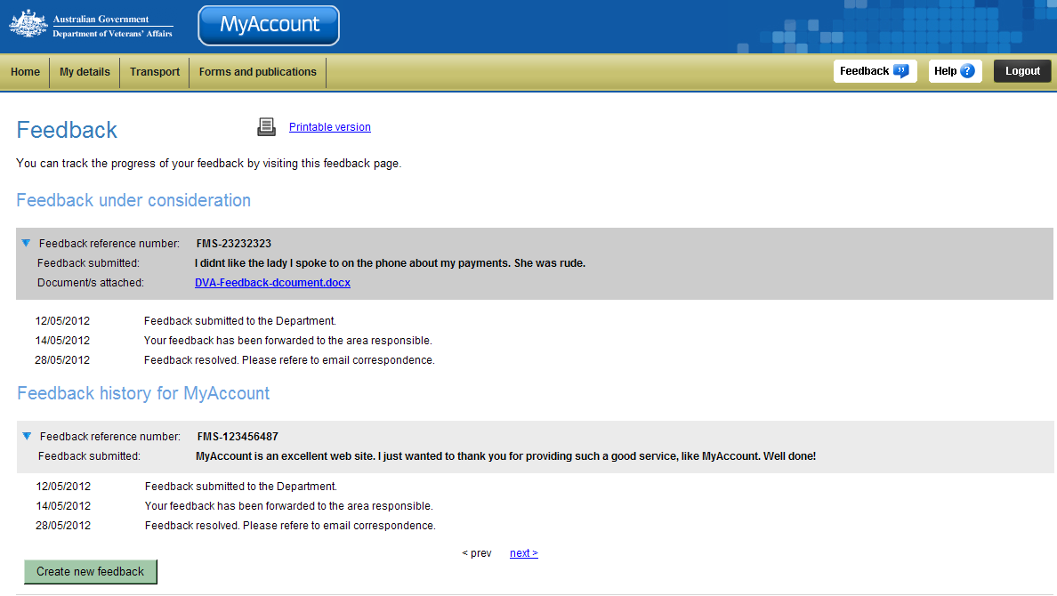
- Review the current status of your feedback.
- To submit further feedback, click on the Create new feedback button.

Other functions
 | To print a copy of the information displayed on this page, click on the Printable version link.
 | To get additional help with the Publications screen, click on the Help button at to the top right of the page.
 | When you are finished using MyAccount, to log out and finish using the service in a secure way, click on the Logout button.

